Parish Council News – October 2021

Parish Council Meetings
The next meetings will be held on Tuesday October 12th and November 9th 2021 at 7.15pm in the Library - members of the public are welcome. Please check our website for any Covid restrictions that may be applicable at the time.

Update from Police Sergeant Paula McDowell
The Parish Council were delighted to welcome our local Police Sergeant Paula McDowell to their September meeting. Residents have been concerned about recent anti-social behaviour, in particular on the Village Green late at night. Sergeant McDowell said that crime is generally very low in Dickens Heath – it is mainly car thefts, with Land Rovers a particular target, and the occasional house break-in. She was not aware of anti-social behaviour on the Village Green. She therefore encouraged all residents to log any ASB problems – via the on-line chat or by ringing 101. She emphasized that the Police can only do something if they are aware of the problem, and logs will be brought to the attention of her team. Instances of vandalism, underage drinking, potential drug taking and ASB should all be logged – to inform the Police of low level problems before they escalate. She added that noise is not a police issue.

Update on Improvements to the Village Green
Due to supply problems, the improvements to the Village Green have been delayed. Most of the replacement benches, 2 new picnic tables and new, larger bins have now been delivered and we are hoping that they will be installed early in October – subject to delivery of the remaining items.

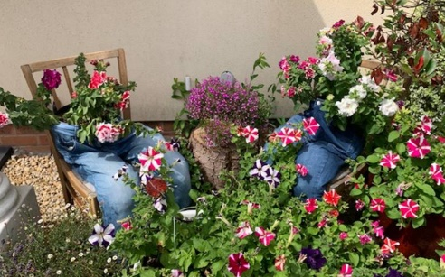
In Bloom and Best Front Garden Competition
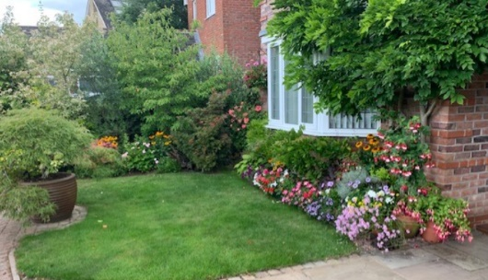

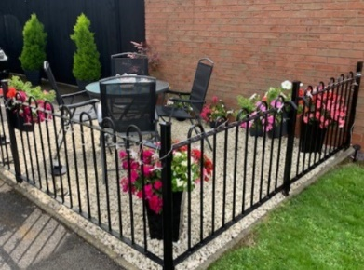
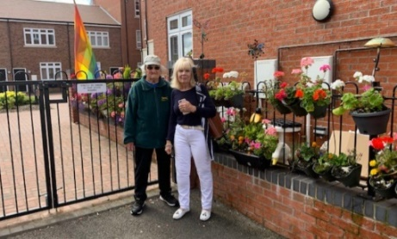
We are delighted that Dickens Heath in Bloom has won a Silver Gilt Award for 2021, thank you to everyone involved. Our judge for the Best Garden Competition, Borough Councillor Ken Hawkins (accompanied by Parish Councillors Maureen Holloway and Doreen Wright), was so impressed with the entrants that he awarded 2 joint first prizes along with 2 runners up. We are planning to award the prizes to the winners at our October meeting.

Trevor Eames
Chair, Dickens Heath Parish Council.

Contact Us:
Dickens Heath Parish Council Tel: 07772 469271, Email: dickensheathpc@hotmail.com www.dickensheathpc.org.uk c/o Dickens Heath Library, Old Dickens Heath Rd, Dickens Heath, Solihull B90 1SD

