Parish Council News – August 2021

Parish Council Meetings
The next meetings will be held on Tuesday September 14th and October 12th 2021 at 7.15pm in the Library - members of the public are welcome. Please check our website for any Covid restrictions that may be applicable at the time.

Update on Improvements to the Village Green
An order has now been placed for replacement benches, some of which will be relocated to more appropriate positions, 2 new picnic tables and new, larger bins. There is a delay in supply, but it is hoped that these will be installed later in the Summer.
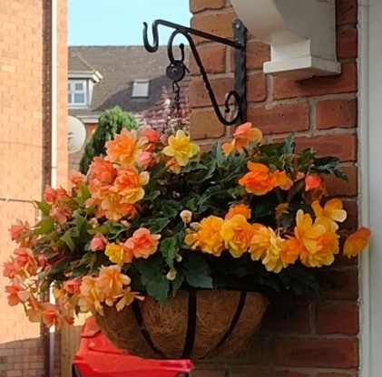

In Bloom – Best Front Garden Competition
We are once again running the best front garden competition – with Borough Councillor Ken Hawkins judging, and prizes for the 3 best gardens. If you would like to enter – please get in touch.

Car Park behind Tesco
The 56 space car park behind Tesco was owned by Elegant Dickens Heath Village Ltd. Ownership of the car park freehold was transferred to the Parish Council on July 9^{th,} at no cost other than legal expenses, as part of the company voluntary winding-up process. Public ownership will safeguard these 56 parking spaces for the community for the future – which is especially important for the village centre where parking can be a particular problem. The seller will be carrying out some remedial works to the car park, and tidying up the landscaping. The car park will have new signage to indicate that it is owned by the Parish Council, but its use will continue as it is currently.

Parish Offices Closed for the Summer
And finally - Helen, our long-standing Clerk, has decided that after 11 years it is time to leave the world of local councils to spend more time with her family. The Parish Offices will therefore be closed over the Summer. Helen will be working reduced hours until our next Clerk is recruited – so if there are delays in getting a reply from the Parish Council, please bear with us during this transitional time and thank you for your patience.

Trevor Eames
Chair, Dickens Heath Parish Council.

Contact Us:
Dickens Heath Parish Council Tel: 07772 469271, Email: dickensheathpc@hotmail.com www.dickensheathpc.org.uk c/o Dickens Heath Library, Old Dickens Heath Rd, Dickens Heath, Solihull B90 1SD

